MARRIOTT INTERNATIONAL MARKET RESEARCH PROPOSAL
ST3188- Statistical Methods for Market Research
ELANGOVAN SUVANESH
UOL Student Number: 230699858
Singapore Institute of Management

Executive Summary:
Marriott International, Inc is an American Multi-National company providing hospitality service operating hotels and restaurants. The company was established almost a hundred years ago in Washington, D.C as a root beer stand. It was opened by J.W Marriott in 1927, which eventually paved the way for a restaurant chain called Hot Shoppes. 58 years later, it transformed into the international hotel company that we recognize today. Marriott International had 418,000 as of December 31, 2024, to serve their customers. They retain customer loyalty through their rewards program and deliver immaculate guest experiences consistently. The study aims to help Marriott International accomplish its objectives by looking into the three marketing problems (MP) which are given in the client brief.
- Marketing Problem 1: Expand global presence by increasing hotel properties and enhancing brand diversity.
- Marketing Problem 2: Deliver exceptional guest experiences by leveraging technology and personalized services.
- Marketing Problem 3: Enhance customer loyalty via the loyalty program and sustainability initiatives.
There are research questions and objectives along with the report to investigate the research aims in-depth with all the statistical methods used to analyse the data that is collected through a Google Forms questionnaire. The essence of this report is to provide Marriott International with an understanding of their customers and competitor customers and effectiveness of their loyalty programs and room for improvement on their steps to sustainability through the analysis.

Table Of Contents

1. | Background
2. | Problem Definition
3. | Research Objectives
4. | Research Design
5. | Data Collection
6. | Data Analysis
7. | Further Research
8. | Conclusion
9. | Questionnaire  1)Questionnaire for Customers  2)Questionnaire for Rival Customers
10. | References

1.BACKGROUND
Mariott International has a global presence from properties outside the United States, such as Asia Pacific and Europe. Marriott International has more than 30 leading brands and nearly 9000 properties across 141 countries. Marriot’s annual revenue for the latest year (2024) was $25.1B, which was a 5.85% increase from the previous year 2023, which totalled to a revenue of $23.71B (Macrotrends, n.d). Marriot International’s market cap as of December 31,2024 is $76.43B USD (Stockanalysis,2025). It is safe to say that Marriot International is a leader in its market, having the highest number of available rooms across the world. After doubling in size over the past decade, Marriot International are currently targeting to save costs between $80 million - $90 million to repose itself, laying off more than 800 corporate employees to aid the matter. Anthony Capuano, president and CEO, called it an “enterprise-wide process to enhance effectiveness and efficiency” (skift,2024). In terms of competitors, Hyatt, Four Seasons and Resorts, Hilton and Wyndham Worldwide Corp are some companies to name a few.

2. PROBLEM DEFINITION
As per the client brief, we have three marketing problems (MP) which are listed below

- Marketing Problem 1: Expand global presence by increasing hotel properties and enhancing brand diversity.
- Marketing Problem 2: Deliver exceptional guest experiences by leveraging technology and personalized services.
- Marketing Problem 3: Enhance customer loyalty via the loyalty program and sustainability initiatives.
This research comes with its aims and strategies to tackle these marketing problems associated with the company.
To tackle Marketing Problem 1,
Research Aim 1 will be to identify new and upcoming trends in travel and destination hotspots.
To tackle Marketing Problem 2
Research Aim 2 will be to investigate guest preferences across different brands and operating segments, for new personalized services and technology integration.
To tackle Marketing Problem 3,
Research Aim 3 plans to study the efficiency of loyalty programs and test certain initiatives for sustainability on customer loyalty.
3. RESEARCH OBJECTIVES
To address each Research Aim (RA) that tackles each marketing problem (MP), we will create Research Questions (RQ) that are specific to each MP, followed by a plausible Research Hypothesis (RH).
- MP1: Expand global presence by increasing hotel properties and enhancing brand diversity.

RQ1.1: How does Marriott International enhance brand diversity in each region they have hotels in?

RQ1.2: What are some of the new travel trends?

RQ1.3: What are some of the economic factors that influence travel behavior for customers?

Research Hypotheses proposed,

RH1.1: Enhance brand diversity by catering their hotels to the region they are situated in, in terms of design, services and experience.

RH1.2: Some of the new travel trends are wellness, spiritual, and nature driven.

RH1.3: Some of the economic factors that influence travel behaviour for customers are exchange rates, transport related costs, and personal budget.

These RHs will help tackle MP1. By designing and customizing the hotel, adding in elements that resonate with the culture of the region will boost brand diversity. It gives cultural immersion for tourists who can have a mild feel of the region before they explore it. It shows effort by the company to provide the best experience for their guests. Travel trends that are emerging are about mental health, self-improvement and having nature-backed life-changing experiences. Providing detailed information through the app or pamphlets that specify these trends will not only benefit customers but will ensure loyalty and retention of customers for Marriott International. Economic factors such as transport around the hotel and exchange rates will affect travel behaviour. Marriott International can help by offering information regarding the currency, arranging transport for a pre-arranged fixed price, and offering travel guides curated to the customer’s personal budgets.

- MP2: Deliver exceptional guest experiences by leveraging technology and personalized services.

RQ2.1: What are some breakthroughs in technologies that Marriott can incorporate to ensure customer satisfaction?

RQ2.2: What are some personalized services that Marriott can implement to ensure customer satisfaction?

Research Hypotheses proposed,

RH 2.1: Some technologies that can be used are incorporating Artificial Intelligence (AI) into hotel applications and technology and incorporating Augmented Reality (AR).

RH2.2: Some of the personalized services that can be implemented are 24/7 access personal assistant, faultless technology integration and exclusive perks.

These RHs will tackle MP2. Incorporating Artificial Intelligence (AI) into hotel applications and features such as chatbots and booking systems will make lives easier for customers who need help with going through the formalities. It would make the booking process seamless and easy to navigate. Incorporating Augmented Reality (AR) provides interactive experience for customers and helps with things like 3D directions and reviews. This will ensure the customers associate their ease of travel with Marriott International, ensuring retention of their customers. Including things like exclusive perks, seamless technology integration, and a 24/7 personal assistant will elevate customer experience and their leisure.

- MP3: Enhance customer loyalty via the loyalty program and sustainability initiatives.

RQ3.1: What are the loyalty programs that Marriott offers that have been a huge factor in securing customer loyalty?

RQ3.2: What are some sustainability initiatives taken by Marriott?

RQ:3.3: How does sustainability initiatives help with customer loyalty?

Research Hypotheses proposed,

RH3.1: The Marriott Bonvoy program offers huge perks to members and retains customers for them to accumulate points.

RH3.2: Marriott’s Serve360 sustainability initiative enhances customer loyalty.

RH3.3: Sustainability initiatives connect customers who are green and have an environmentalist mindset, therefore making them enthusiastically support the company for their green movements.

These RHs will tackle MP3. The Marriott Bonvoy allows customers to accumulate points and unlock amazing benefits. Some of them are member room rates, enhanced room upgrades, late checkouts and allowing customers to combine points and cash to pay for their stay. This gives customers additional incentives as they book their stay at Marriot, cementing brand loyalty (Marriott, n.d). Marriott’s Serve360 sustainability initiative reduces environmental impacts, makes their hotels practice sustainable measures and builds their hotel sustainably with the resources they use. By 2025, They also aim to demand all centrally contracted suppliers to provide information on product sustainability, inclusive of social and human rights impacts, and are committed to sourcing 100% of their eggs from cage-free sources (Marriott, n.d). This enhances customer loyalty. Customers who are environmentalists and green resonate with Marriot’s efforts and values associated with sustainability, pulling them closer towards the company and making them want to be a part of the green movement. This cements brand loyalty.

4. RESEARCH DESIGN
The RQs for this research have been curated specifically to incorporate descriptive research design and exploratory research design to have thorough information. This will aid Marriott International and their attempts to fully understand their customers. The descriptive research will investigate guest preferences across different brands and the effectiveness of sustainability. The exploratory research will aid Marriott in delivering exceptional guest experiences by figuring out new travel trends and desires for customers. Primary data will be collected by making an online survey leading to focus groups while secondary data is derived from Marriott’s customer database. The quantitative approach will be for aims that use statistical techniques to create hypothesis whereas the qualitative approach will be for aims that demands research into the factors where there is room for improvement for Marriott International.

5. DATA COLLECTION
We will be using questionnaires for this research. Questionnaires need little to no budget and they are extremely straight forward to implement. They allow Marriott International to gather information on customer preferences, travel behaviours and feedback on their service. There will be a 2-stage random sampling. There are Marriot customers, and customers from rival companies. For Marriott customers, the first stage will be to narrow the sampling of customers by region. The second stage will be to randomly select customers from these different regions.
The regions that are picked for the research are the regions with the highest number of properties for Marriott International (2016-2023), which are North America, Europe, Asia Pacific excluding China and Greater China (Statista,2024). For customers from rival companies, as there is no sampling frame, convenience sampling will be used due to the customers being the easiest to access.
As for the sample size for customers, it is suggested that we use a sample size of 5000. To calculate the apt sampling size (customers and rival customers) for this research, we use a 95% confidence interval with a 5% margin for error, along with an 80% compliance rate. The sample size is given by,

$$n≥\frac{{Z_{\frac{∝}{2}}}^{2}\left(π \left(1-π\right)\right)}{e^{2}}$$

$$n≥\frac{{1.96}^{2}\left(0.8\left(0.2\right)\right)}{{0.05}^{2}}=245.8624≈246$$
The sample size per region will be around 246 customers. Therefore, sample size for customers will be,
$$246×4=984≈1000$$

For the sample size of customers from rival companies, we use a 95% confidence interval with a 5% margin error and 40% compliance rate due to the inconsistent nature of these customers. Therefore, the sampling size will be,

$$n≥\frac{{Z_{\frac{∝}{2}}}^{2}\left(π \left(1-π\right)\right)}{e^{2}}$$
$$n≥ n≥\frac{{1.96}^{2}\left(0.4\left(0.6\right)\right)}{{0.05}^{2}}=368.7936≈369$$

Therefore, the total sample size n, for the questionnaire, will be 1369 volunteers.
There will be 2 types of questionnaires provided to the 2 types of people. One will be issued to customers of Marriott and the other will be issued to rival customers. Questions regarding their bio data and their financial background will be asked, allowing us to understand our customers better. It will be done physically through campaigns inside the hotels and digitally through QR and copy paste links. There will be a dry run of the questionnaires to test and prevent digital and physical errors.

VARIABLE | DATA TYPE
AGE | Continuous
GENDER | Categorical Nominal
COUNTRY | Categorical Nominal
MONTHLY INCOME | Continuous
FREQUENCY OF STAYING IN HOTELS | Ordinal
MEMBERSHIP TIER | Categorical
MOST ENJOYED BENEFITS | Nominal
VIEW ON SERVE360 | Ordinal
OVERALL EXPERIENCE | Continuous (Numerical Rating)

6. DATA ANALYSIS
The following will explain whether the RQs demand a qualitative or quantitative analysis. It will be followed by the statistical analysis that is chosen for the respective RQ.
RQ1.1: How does Marriott International enhance brand diversity in each region they have hotels in?
This RQ requires a qualitative analysis. Carry out Focus Groups to understand how Marriot can enhance brand diversity in various ways including but not limited to customization, sustainability and campaigns. Therefore, this analysis will prove the RH proposed.

RQ1.2: What are some of the new travel trends?
This RQ demands a quantitative analysis. We will carry out a Regression Analysis for the RQ. Before the Regression, we will perform descriptive statistics and correlation matrix table.

Variables | Mean | SD | Min | Max
Age group (Years)
Income Category ($)
Budget Group ($)
Trend Popularity (%)

The means of all the variables provide the average value, the standard deviation will indicate higher/lower variability and the range is given by min and max values.

Correlation Matrix
Variables | Age group | Income Category | Budget Group | Trend Popularity
Age group | 1
Income Category |  | 1
Budget Group |  |  | 1
Trend Popularity |  |  |  | 1

Focuses on the numerical correlation of every possible pair of variables ranging from -1 to +1.

Now, we are moving to the Regression Analysis tables,
Variables | Coefficient | SE | t-value | p-value | Significance
Constant
Age group
Income Category
Budget Group
Trend Popularity

Gives a conclusion whether the variables are of sizeable importance or not. t-values and p-values provide information on the importance of the variables, values high enough but below 0.05 can be concluded as important.

Model Summary Table
R- Square
Adjusted R-Square
F-Statistic
P-value

Determines the overall importance of the regression model. R-squared value indicates about the explanatory power of the model.

ANOVA
 | Sum of Squares | Degrees of Freedom | Mean Square | F-value | p-value | Significance
Between Groups
Within Groups
Total

Therefore, this analysis will prove the relation between the many different variables to new emerging trends, proving the RH.

RQ1.3: What are some of the economic factors that influence travel behavior for customers?
This RQ demands a quantitative analysis as well. Therefore, similar to RQ1.2, We will carry out a Regression Analysis.

Variables | Mean | SD | Min | Max
Income Category ($)
Travel Budget ($)
Exchange Rate ($)

Correlation Matrix
Variables | Income Category | Travel Budget | Exchange Rate
Income Category | 1
Travel Budget |  | 1
Exchange Rate |  |  | 1

Regression Analysis tables,
Variables | Coefficient | SE | t-value | p-value | Significance
Constant
Income Category
Travel Budget
Exchange Rate

Model Summary Table
R- Square
Adjusted R-Square
F-Statistic
P-value

ANOVA Table
 | Sum of Squares | Degrees of Freedom | Mean Square | F-value | p-value | Significance
Between Groups
Within Groups
Total

Therefore, this analysis explains the relation between the many economic factors and how it can influence travel behaviour among customers, proving the RH.
RQ2.1: What are some breakthroughs in technologies that Marriott can incorporate to ensure customer satisfaction?
This RQ demands quantitative analysis. We will conduct a Factor Analysis. Before conducting a Factor Analysis, we will have to derive the basic metrics.

Variables | Mean | SD | Min | Max
AI Acceptance Rate in applications and websites
AR Acceptance Rate in applications and websites

The means of all the variables provide the average value, the standard deviation will indicate higher/lower variability, and the range is given by min and max values.

To verify if the data given warrants a Factor Analysis, we carry out a Kaiser-Meyer-Olkin (KMO) and Barlett’s Test of Sphericity(p-value)

KMO Value
p-value

KMO value close to 1 will mean the data warrants a Factor Analysis and p-value will do the same when it is less than 0.05.
Table of Total Variance
Factor | Eigenvalue | % of Variance Explained | Cumm % of Variance
1
2
3
…

This table shows how much information each factor amounts to in comparison to the data. Eigenvalues being more than 1 will mean the factor can be accepted.

Factor Loadings Table
Variable | Factor 1 | Factor 2 | Factor 3 | …
AI
AR

This table is to show numerically how much the variables account for each of the factors with >0.5 values having a huge contribution and <0.5 having a small contribution.

Factor Score Coefficients Table
Variables | Factor 1 score | Factor 2 score | Factor 3 score | …
AI
AR

The coefficients multiplied by the variable gives the factor score.

Therefore, this analysis explains how both variables act as emerging technologies that can influence customer satisfaction, proving the RH.

RQ2.2: What are some personalized services that Marriott can implement to ensure customer satisfaction?
This RQ demands a quantitative analysis. We will carry out a Multiple Regression Analysis as we need to link the many independent variables to a dependent variable. Upon conducting a descriptive statistics table and a correlation matrix table to compute the basic metrics, we move to the next few tables
Model Summary Table
R- Square
Adjusted R-Square
F-Statistic
P-value

Regression Coefficients Table
Variables | Unstandardised Coefficients | SE | Standard Coefficients | t-statistic | p-value
Constant
Personal Assistant
Technology Integration
Exclusive Perks

This table is to show the relation between an independent variable and a dependent variable. Unstandardised Coefficients are changes in customer satisfaction scores upon an increase in any variable. Standardised variables are relation between variable and their impact on customer satisfaction.

ANOVA Table
 | Sum of Squares | Degrees of Freedom | Mean Square | F-value | p-value
Regression
Residual
Total

Therefore, this analysis proves the RH by explaining the relation between the many different personalized services to customer satisfaction.
RQ3.1: What are the loyalty programs that Marriott offers?
This RQ demands a qualitative analysis. Carry out focus groups within customers from various membership tiers to have an insight into new benefits and changes that could be made.

RQ3.2 and RQ3.3:
Both RQs require a qualitative analysis. Carry out surveys to measure the success of sustainability and understand the factors that made Serve360 a huge success, link it to brand loyalty.

7. FURTHER RESEARCH

Apart from every area that has been discussed and explained to boost Marriot’s business, there are other factors that the database didn’t cover. Factors like Employee Wellness, Impact of Marriott’s presence on Local Communities, Marriott’s Social Media Performance can be studied to identify any underlying metrics that can be maximized, propelling the business into new heights.
Employee Wellness directly affects the quality of service, and the efficiency of hotel operations thus affecting overall performance.
The impact of Marriott’s presence on Local Communities can change how people view Marriott if the metrics regarding employment rates, tourism scale, and GDP of the respective country are marketed accordingly.
Marriott’s Social Media Performance can be a huge room for improvement as in this day and age, digital presence matters, and marketing campaigns can be done in a cost-effective way while reaching millions of people around the world. It can pull the younger customer demographic, ultimately increasing brand exposure and revenue.
Building on strengths such as initiatives on sustainability will also boost brand exposure and cement Marriott’s reputation as an eco-friendly hotel chain even further.

8. CONCLUSION
This research proposal dived into various Marketing Problems, Research Aims, Research Hypotheses and the statistical techniques used to prove the Research Hypotheses. Through intensive research and investigation into the business, various factors influencing customer preferences, satisfaction, and travel behaviours were uncovered and were also shown how they would maximise Marriott’s business. Marriott’s huge success upon expanding into different regions lie on their initiatives to promote sustainability, their loyalty programs and their overall guest experience. Strengthening on factors that makes Marriott what they are today and improving on factors that Marriott can do better within a short time frame is crucial. Upon approval from Marriott regarding this report, the six-month research will commence within the agreed budget.

9. QUESTIONNAIRES

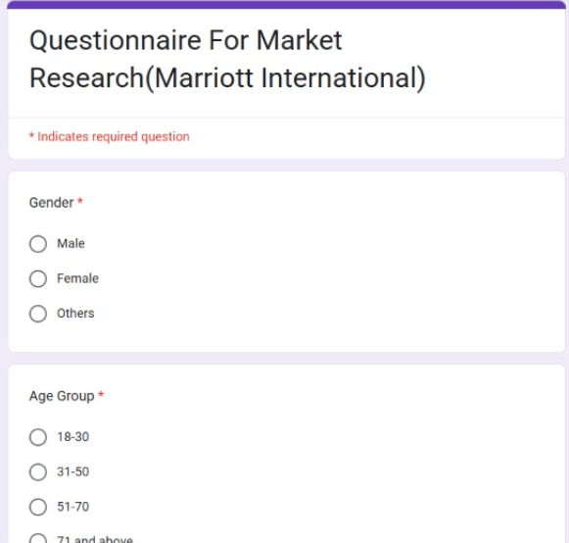
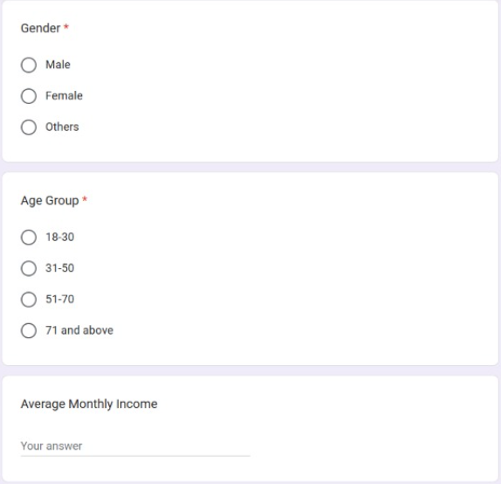
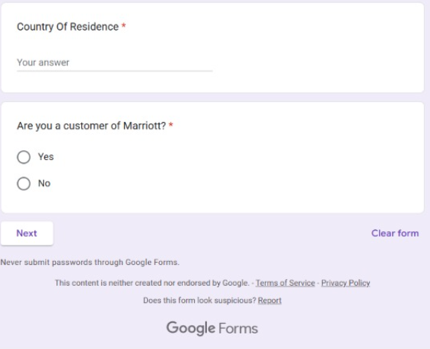

- QUESTIONNAIRE FOR CUSTOMERS OF MARRIOT INTERNATIONAL

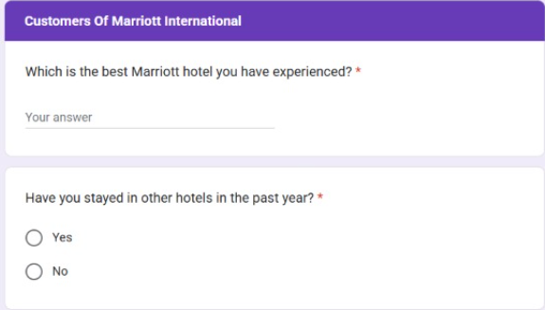

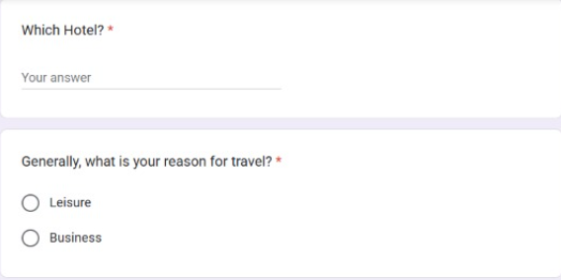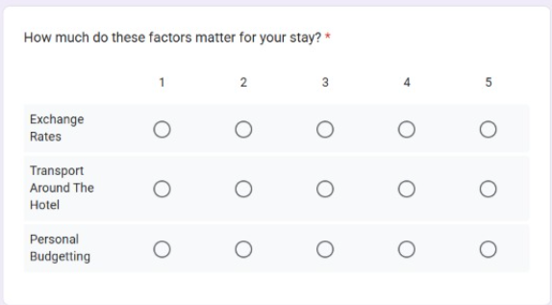
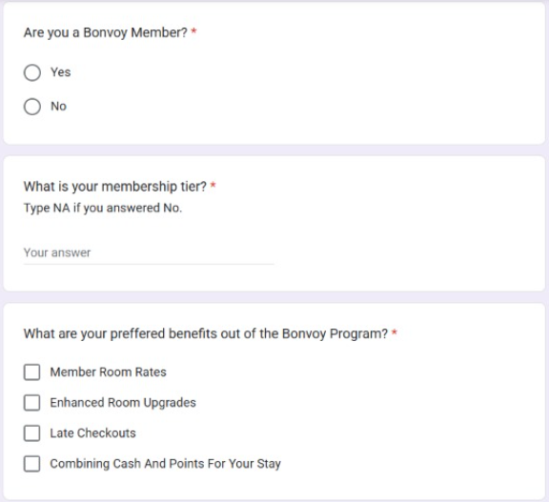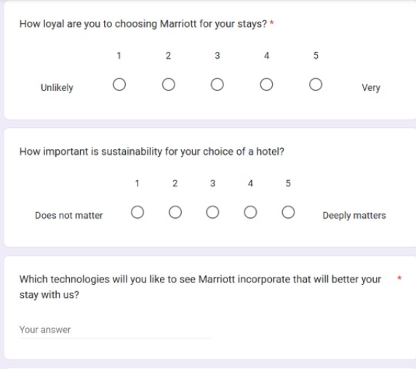
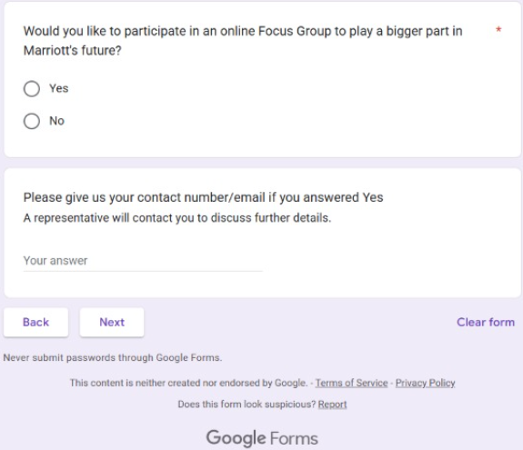

- QUESTIONNAIRE FOR RIVAL CUSTOMERS

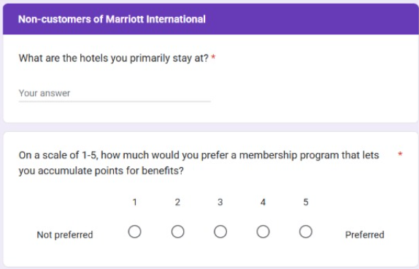
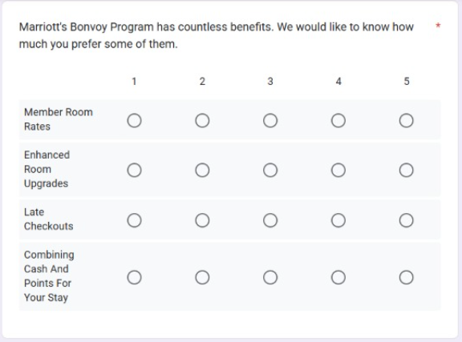
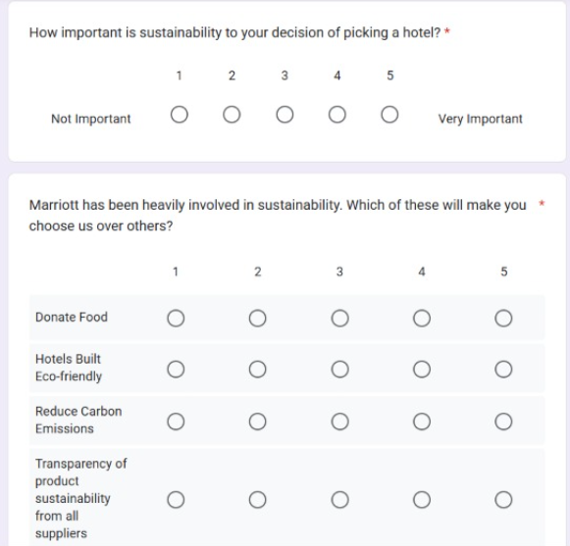
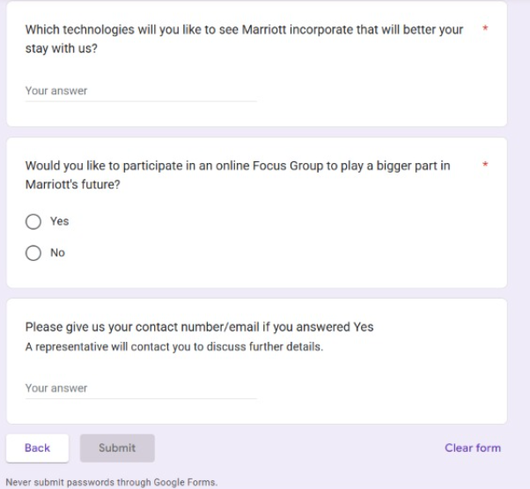

10.REFERENCES
1)
https://www.macrotrends.net/stocks/charts/MAR/marriott/revenue#:~:text=Marriott%20annual%20revenue%20for%202023,a%2031.09%25%20increase%20from%202020 – Marriott’s Revenue
2)
https://stockanalysis.com/stocks/mar/employees/#:~:text=Marriott%20International%20Employees,compared%20to%20the%20previous%20year - Marriott’s Market Cap
3)
https://skift.com/2024/11/04/marriott-unveils-overhaul-cut-costs-push-midscale-brands-boost-loyalty/#:~:text=Marriott%20plans%20a%20significant%20organizational,a%20year%2C%20starting%20in%202025 – Marriot’s Cost Cutting Details
4)
https://serve360.marriott.com/sustain/#:~:text=We%20minimize%20our%20environmental%20footprint,communities%20in%20which%20we%20operate – Marriot’s Serve360 Program
5)
https://www.marriott.com/loyalty.mi - Marriot Bonvoy Rewards Program
6)
https://www.statista.com/statistics/297262/number-of-marriott-international-properties-worldwide-by-region - Highest Number of Properties Per Region for Marriott International, Inc.

